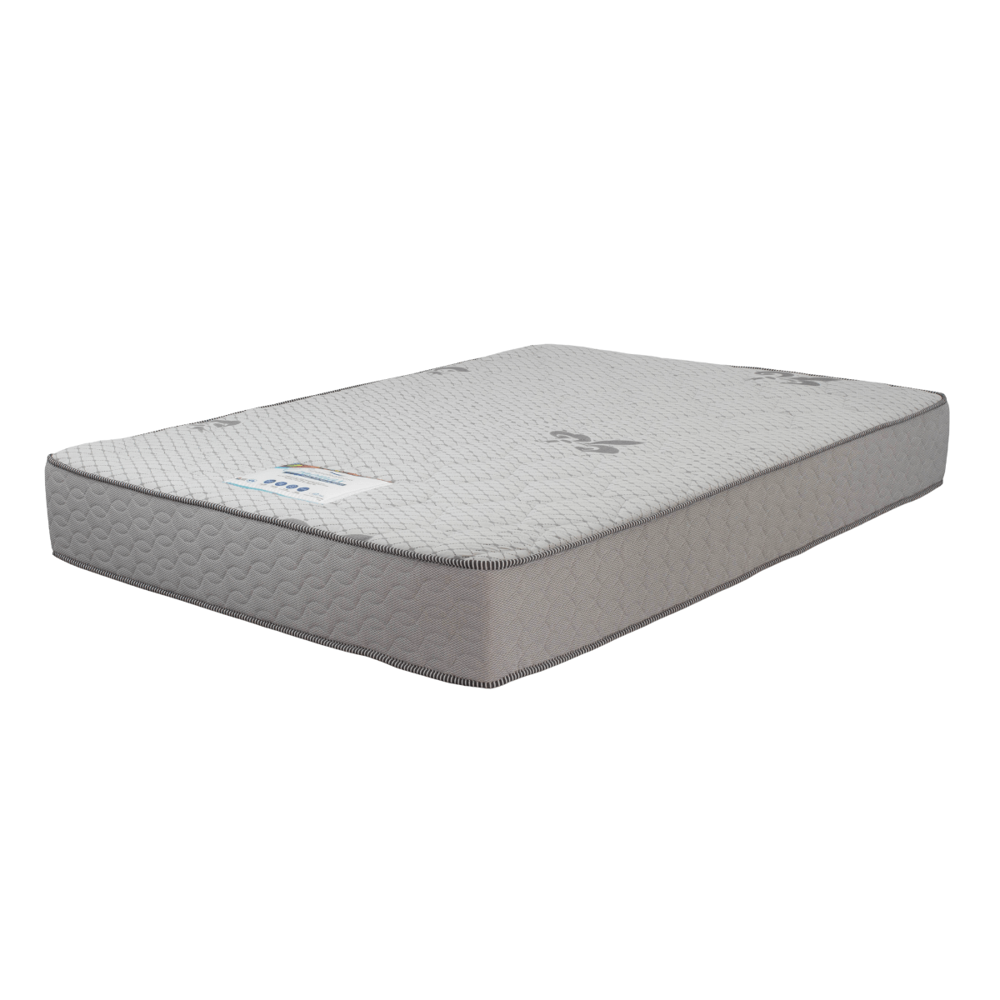
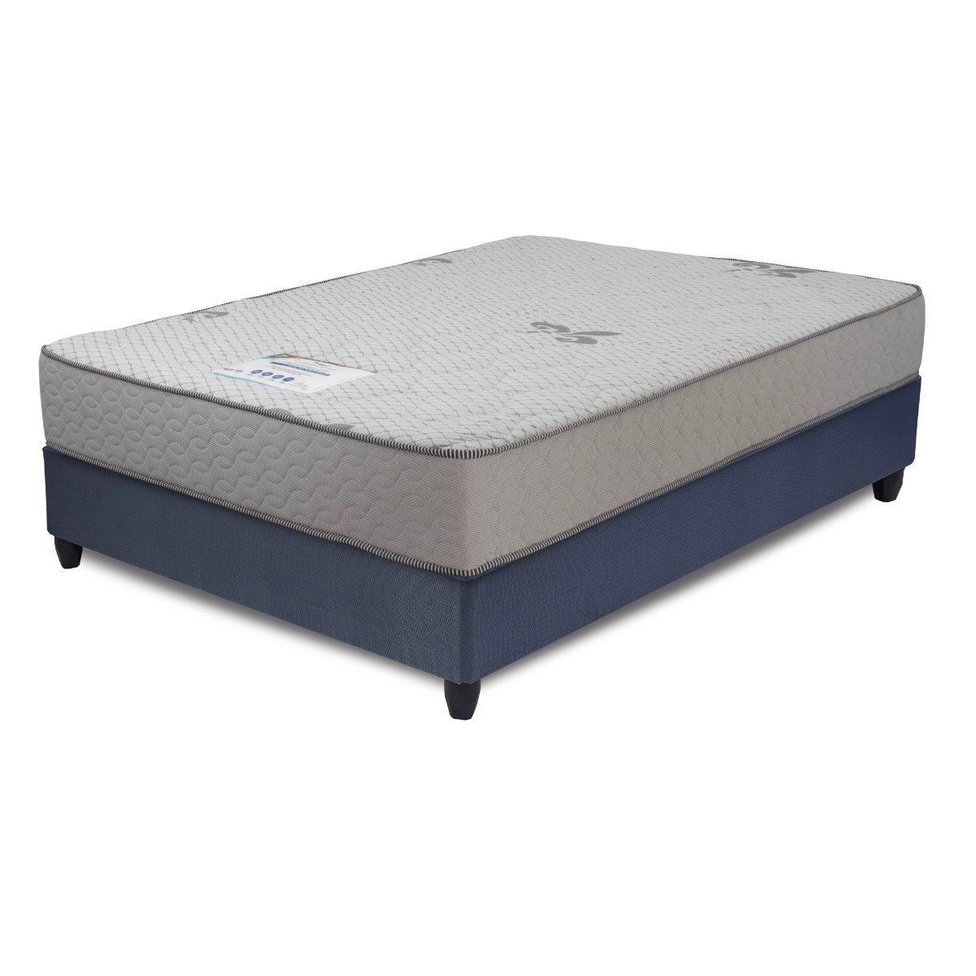


Model : Ergomax Bed Set
Supplier/Manufacturer : Cloud Nine
Range : Strandmattress
Prices – Bed Set :
- Single Bed Set – R3059
- Three Quarter Bed Set – R3479
- Double Bed Set – R4099
- Queen Bed Set – R4459
Prices – Mattress Only :
- Single Mattress Only – R1809
- Three Quarter Mattress Only – R2059
- Double Mattress Only – R2559
- Queen Mattress Only – R2829
*This model isn’t available in King Size or in Extra Length*
*Please use this link for guideline for creating the page* - https://www.bedsonline.co.za/product/strandmattress-ergomax-medium-firm-queen/

